Practical - 5
Practical Title: Registration Form with Frontend Validation and User-Friendly Error Handling
Problem Definition: Create a student registration form with HTML5 input types and JavaScript validation for name, email, mobile number, password, confirm password, course, year, gender, and terms acceptance. Use Regular Expression for validations.

Theory :
1. Are correct input types and attributes used?

Yes, correct input types and attributes are used. Text is used for names, email for email addresses, password for passwords, and the required attribute ensures that mandatory fields cannot be left empty.

2. Are validation errors displayed near the relevant fields?

No. Validation errors are currently displayed through alert messages rather than near the relevant input fields.

3. Is password strength checked?

Yes, password strength is checked using JavaScript validation with minimum length and character requirements.

4. Is the form accessible using keyboard and screen-reader-friendly labels?

Partially. Keyboard access is supported, but labels should be linked to their corresponding input fields using the for attribute for better screen-reader accessibility.

Validation:
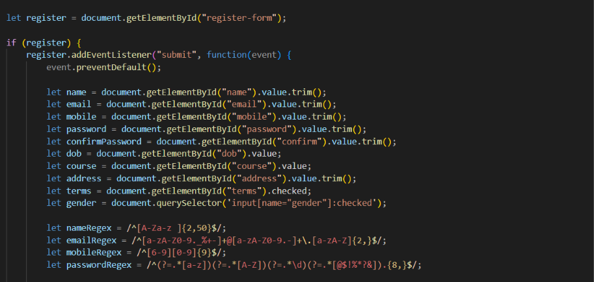

Implementation/ Output/Result
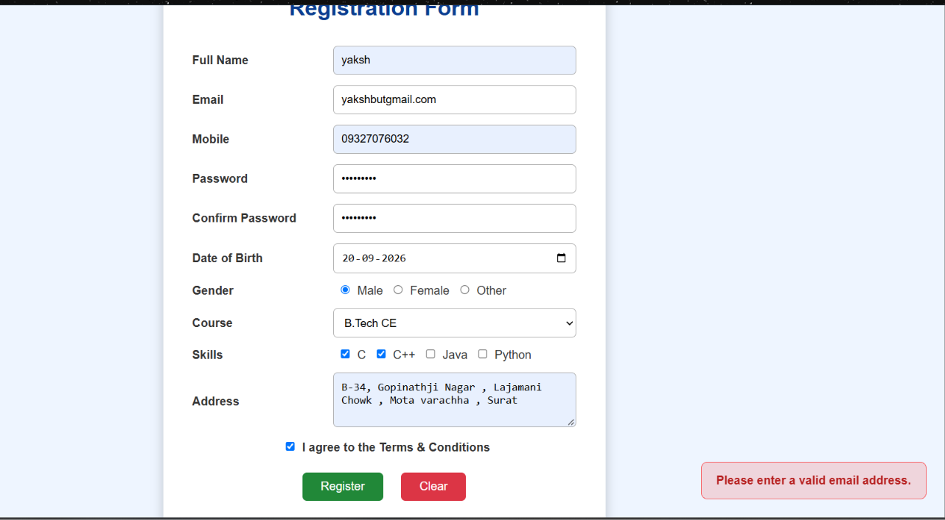
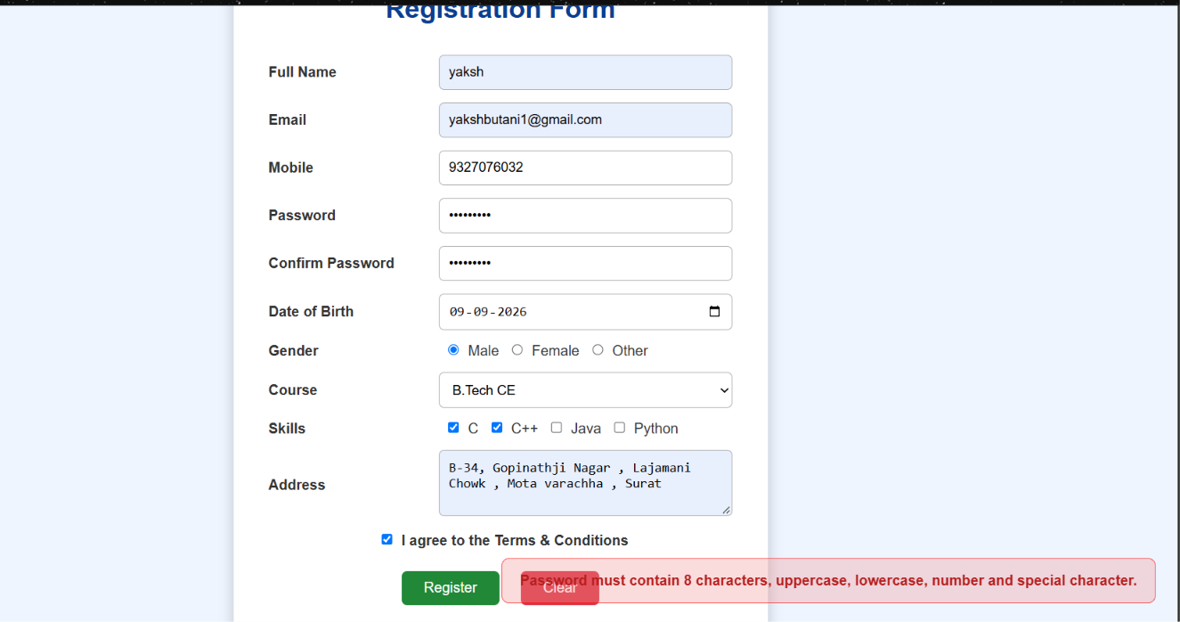
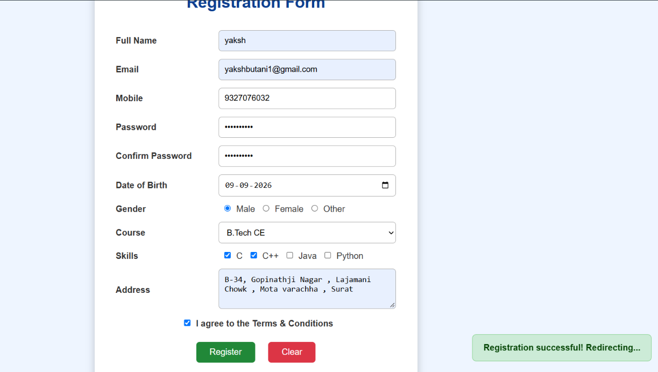

GitHub Repository Link:
https://github.com/yakshu205/StudentHub.git

Learning Outcomes:
- Understand HTML form creation and different input types.
- Implement client-side form validation using JavaScript.
- Use Regular Expressions for validating user inputs.
- Implement password strength and confirmation checks.
- Handle validation errors and provide user-friendly messages.
- Understand basic form accessibility for keyboard and screen-reader users.

Faculty Remarks: (Keep this blank for faculty)

